***QUESTION 4 : IDENTIFY A SET OF USER STORIES AND CORRESPONDING ACCEPTANCE TESTS THAT WILL BE USED AS THE BASIS FOR REQUIREMENTS VALIDATION FOR THE CHOSEN FUNCTIONALITY AS OUTLINED IN (1)***

A user story is what is used to describe the functionality that will be valuable to either stakeholders of the software.

User Story 1: The User should be able to login to the system

Acceptance Tests :

1. Test with the correct username and password
2. Test with incorrect username and password
3. Test with with usernames and passwords with characters missing

User Story 2: Creating another user account

Acceptance Test:

1. Test by creating an account with the username and password in the correct format
2. Test by creating an account with the username and password in the incorrect format
3. Try to create an account by using a username that already belongs to an existing account.

User Story 3: Setting up meeting times and adding special requirements

Acceptance Test:

1. Test by setting up a meeting and adding it to a user
2. Test by accepting and declining meetings
3. Test by adding a special requirement for a specific user that is needed for them at the meeting

User Story 4: A list of attendees should be made when bringing up the details of a meeting

Acceptance Test

1. Test by adding users to a meeting and running the program to display the users for a meeting
2. Test to see if you can add a user to a meeting more than once
3. Test to see if you can remove a user from a meeting and it will be displayed on the list

***QUESTION 5 : PRODUCE A SET OF TEST SCRIPTS (OR SCENARIOS) FOR USER STORES FOR VALIDATION PURPOSES. THESE TESTS (OR SCRIPTS) SHOULD MODEL HOW THE INTENDED SOFTWARE SYSTEM MAY BE USED FROM THE USERS’ PERSPECTIVE AND SHOULD ALSO MODEL WHAT CAN GO WRONG WHILE EXECUTING THEM.(***

***Test 1 : User Story 1 - Acceptance Test 1***

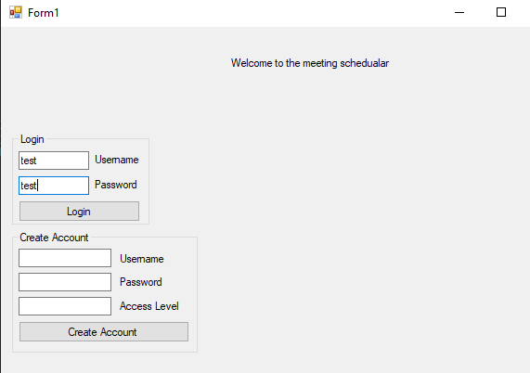

***These were the login credentials I used to login to the system***

***This was successful as it brought me inside the system and is now displaying options to select a meeting time, as well as see meeting invites and log out of the system.***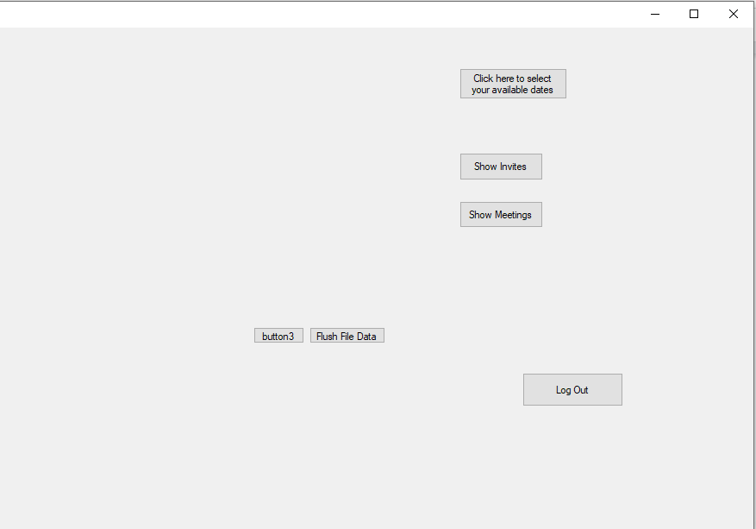

***Test 2 - User Story 1 - Acceptance Test 2***

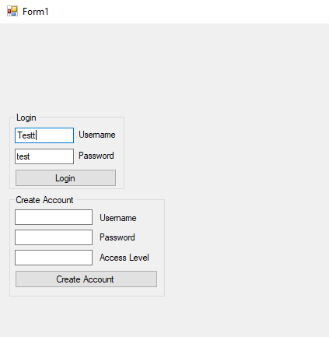

***These were the login credentials I used to login to the system, once clicked I was not given access to the system where I can access meetings so the login was unsuccessful.***

***Test 3 - User Story 1 - Acceptance Test 3***

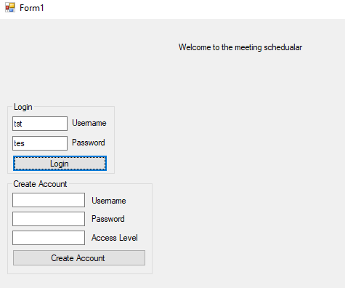

***I entered the login details of a user, but in this case there were characters missing in the username and password, once login was clicked access to the system was not allowed.***

***Test 1 : User Story 2 - Acceptance Test 1***

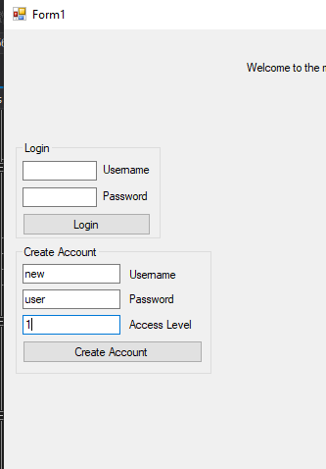

***These are the credentials of the new user account i wanted to create***

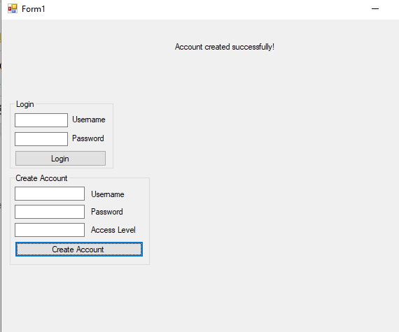

***This output the message account created successfully as the format of the username and password was correct***

***Test 2 : User Story 2 - Acceptance Test 2***

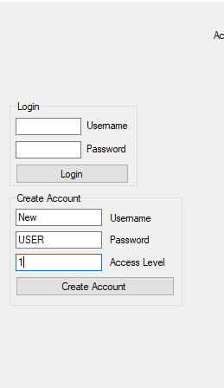

***These were the credentials of the new user I wanted to create***



***When the create account button was clicked, this exception was thrown and the program was stopped.***

***Test 3 : User Story 2 - Acceptance Test 3***

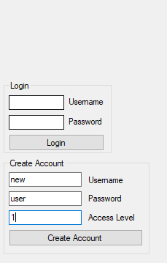

***I entered the same details I did when I created a new account in acceptance test 1 of User Story 2.***

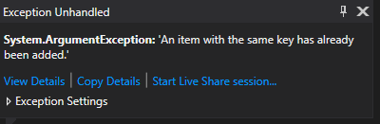

***This exception was thrown when the create account button was clicked.***

***Test 1 : User Story 3 - Acceptance Test 1***

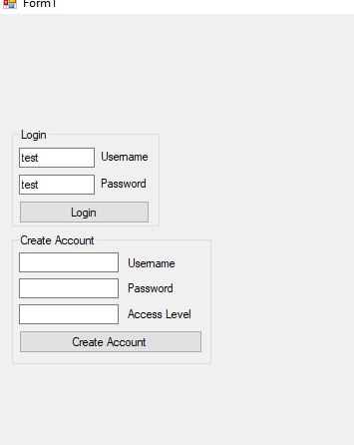

***Firstly, i logged in with the correct details***

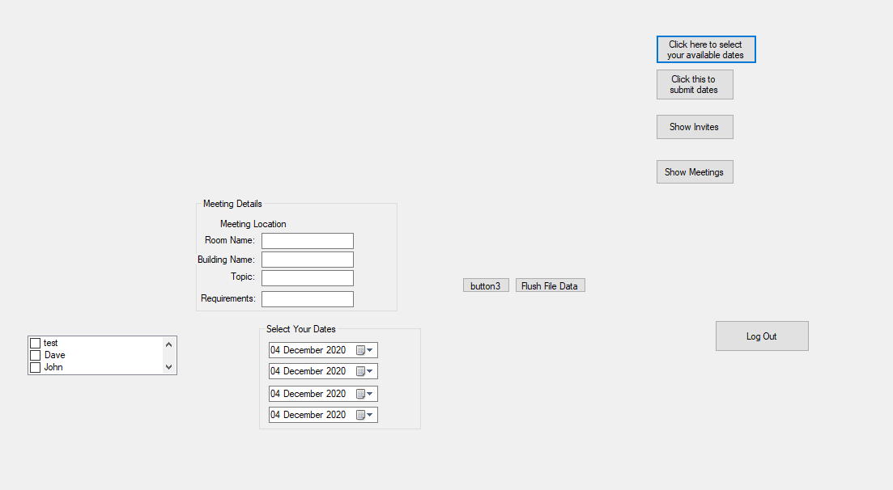

***I then clicked select available dates, I am going to set up a meeting for the 4th of December. I will then select a user to have a meeting with.***

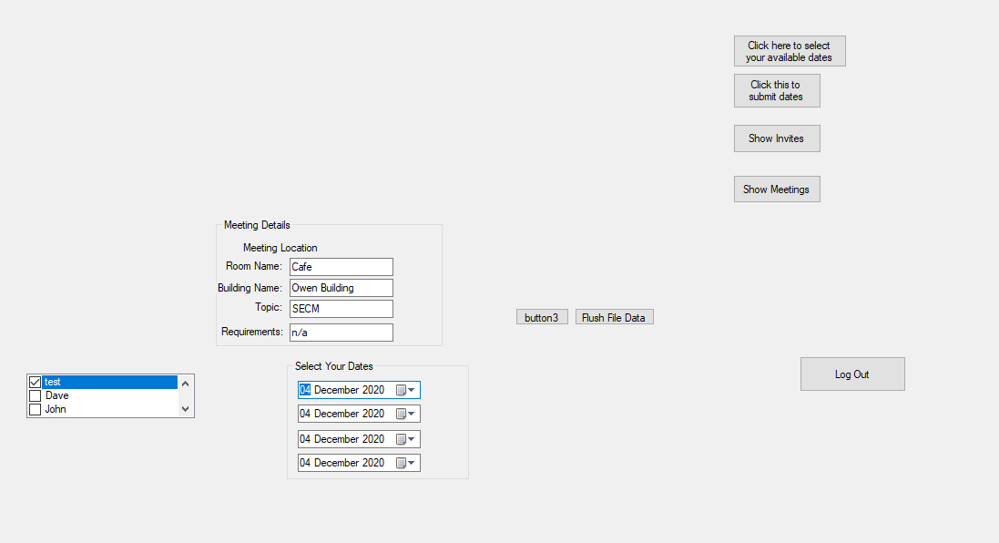

***I then put in the details of the meetings and clicked submit***

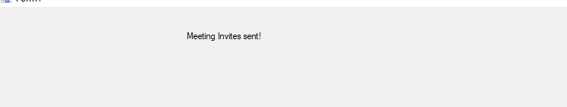

***The message “Meeting invites sent” was displayed***

***Test 2: User Story 3 - Acceptance Test 2***

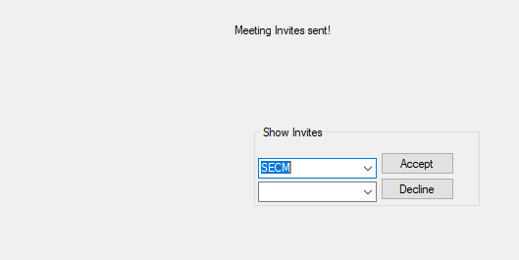

***Under the user i logged in with i was able to select the meeting and i clicked accept***

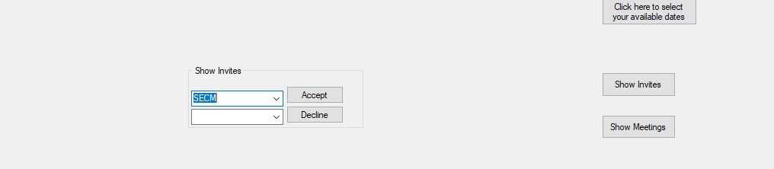

***I then logged into the account of the user i set up the meeting with i selected the meeting and clicked decline***

***Test 3 : User Story 3 - Acceptance Test 3***

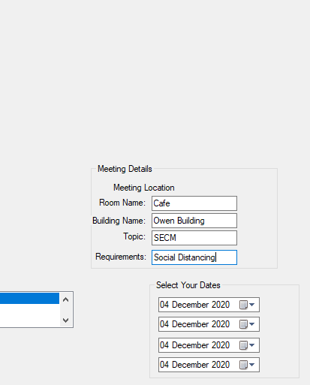

***For this meeting i set it up with the requirement that there needs to be social distancing***